
CS361 – Web Programming
Campus Events Hub
Individual Completed Work and Technical Solution
Student Name | Azd Ahmed Rawah
Student ID | S230011850
Assigned Role | Database Design, PHP Database Connection, Registration Form, Validation, and Insertion
Project | Campus Events Hub
This file contains the completed implementation corresponding to the tasks assigned to this student in the submitted project records.
1. Assigned Tasks
Week | Date | Task as Recorded
Week 1 | 15/07/2026 | Planned the database fields needed for events and registrations.
Week 2 | 22/07/2026 | Created the first version of the registration form.
Week 3 | 29/07/2026 | Created the database connection and helped prepare the SQL tables.
Week 4 | 05/08/2026 | Implemented form validation, prepared statements, and duplicate-registration prevention.
Week 5 | 09/08/2026 | Retested the database connection and registration validation.
2. Completed Solution
- Designed separate events and registrations tables with a foreign-key relationship.
- Added a composite uniqueness rule for student_id and event_id to prevent duplicate registrations.
- Created the reusable MySQL connection file with UTF-8 support and a clear connection-error response.
- Built the registration form and retained submitted values when validation errors occur.
- Validated required fields, minimum name length, student-ID pattern, email format, and selected-event validity.
- Used prepared statements for event lookup, duplicate checking, and registration insertion.
3. Visual Evidence
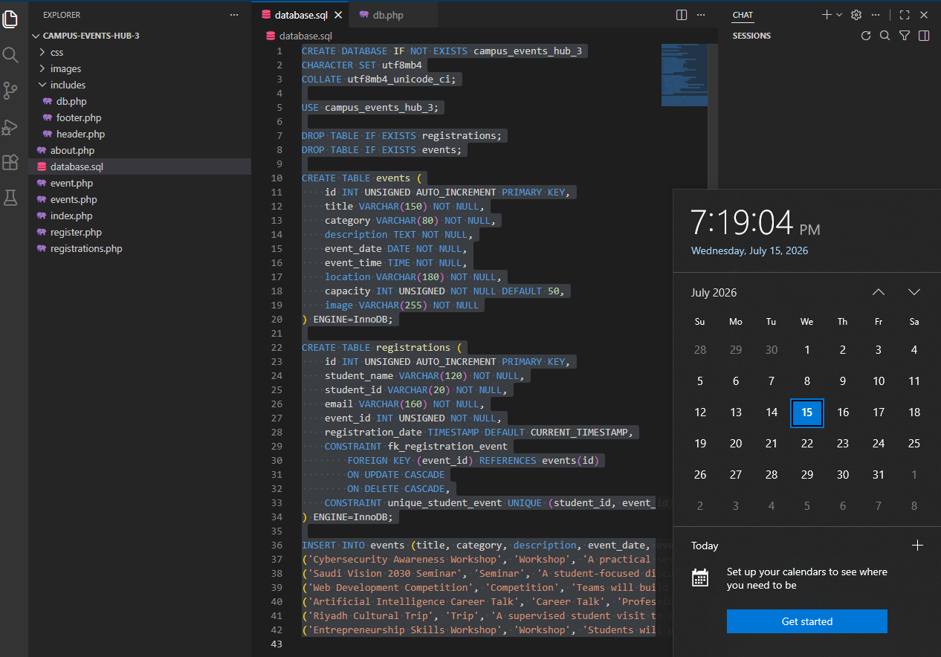
Database schema and event records prepared for the PHP website.
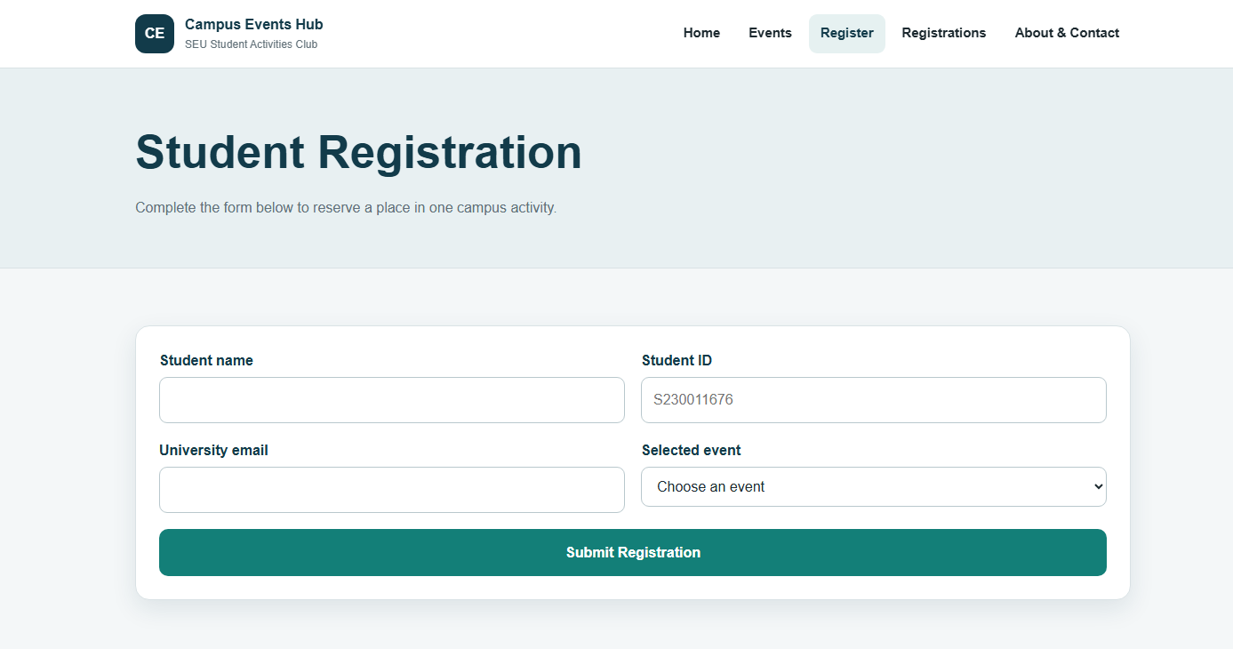
Completed Registration page connected to server-side processing.
4. Verification Results
Test | Expected / Recorded Result | Status
Submit empty form | The required-fields error is displayed. | Pass
Enter a name shorter than three characters | The minimum-name-length error is displayed. | Pass
Enter an invalid student ID or email | The relevant format error is displayed. | Pass
Choose an invalid event value | The form rejects the event selection. | Pass
Submit the same student/event twice | Duplicate registration is prevented. | Pass
Submit valid new data | The registration is inserted and a success message appears. | Pass

5. Relevant Source-Code Solution
The following code is taken from the submitted project source files and corresponds directly to the student's assigned implementation.
includes/db.php
<?php
$host = 'localhost';
$user = 'root';
$password = '';
$database = 'campus_events_hub_3';
$conn = mysqli_connect($host, $user, $password, $database);
if (!$conn) {
die('The website cannot connect to the database at the moment. Please try again later.');
}
mysqli_set_charset($conn, 'utf8mb4');
?>

database.sql
CREATE DATABASE IF NOT EXISTS campus_events_hub_3
CHARACTER SET utf8mb4
COLLATE utf8mb4_unicode_ci;
USE campus_events_hub_3;
DROP TABLE IF EXISTS registrations;
DROP TABLE IF EXISTS events;
CREATE TABLE events (
id INT UNSIGNED AUTO_INCREMENT PRIMARY KEY,
title VARCHAR(150) NOT NULL,
category VARCHAR(80) NOT NULL,
description TEXT NOT NULL,
event_date DATE NOT NULL,
event_time TIME NOT NULL,
location VARCHAR(180) NOT NULL,
capacity INT UNSIGNED NOT NULL DEFAULT 50,
image VARCHAR(255) NOT NULL
) ENGINE=InnoDB;
CREATE TABLE registrations (
id INT UNSIGNED AUTO_INCREMENT PRIMARY KEY,
student_name VARCHAR(120) NOT NULL,
student_id VARCHAR(20) NOT NULL,
email VARCHAR(160) NOT NULL,
event_id INT UNSIGNED NOT NULL,
registration_date TIMESTAMP DEFAULT CURRENT_TIMESTAMP,
CONSTRAINT fk_registration_event
FOREIGN KEY (event_id) REFERENCES events(id)
ON UPDATE CASCADE
ON DELETE CASCADE,
CONSTRAINT unique_student_event UNIQUE (student_id, event_id)
) ENGINE=InnoDB;
INSERT INTO events (title, category, description, event_date, event_time, location, capacity, image) VALUES
('Cybersecurity Awareness Workshop', 'Workshop', 'A practical session about safe passwords, phishing messages, account protection, and responsible use of university systems. Students will work through short real-life examples.', '2026-08-02', '16:00:00', 'SEU Riyadh Campus - Training Hall 2', 60, 'images/event-workshop.jpg'),
('Saudi Vision 2030 Seminar', 'Seminar', 'A student-focused discussion about Vision 2030, digital transformation, future skills, and how university graduates can contribute to national development.', '2026-08-04', '13:30:00', 'SEU Riyadh Campus - Main Auditorium', 120, 'images/event-seminar.jpg'),
('Web Development Competition', 'Competition', 'Teams will build a small responsive website during a timed challenge. Projects will be evaluated for usability, design, code organization, and presentation.', '2026-08-06', '10:00:00', 'SEU Dammam Campus - Computer Lab 4', 48, 'images/event-competition.jpg'),
('Artificial Intelligence Career Talk', 'Career Talk', 'Professionals from the Saudi technology sector will discuss entry-level AI careers, required skills, internships, and responsible use of intelligent systems.', '2026-08-09', '18:00:00', 'Online through SEU Virtual Classroom', 200, 'images/event-ai.jpg'),
('Riyadh Cultural Trip', 'Trip', 'A supervised student visit to cultural and historical locations in Riyadh. The trip supports social connection and awareness of local heritage.', '2026-08-12', '08:00:00', 'Departure from SEU Riyadh Campus', 40, 'images/event-trip.jpg'),
('Entrepreneurship Skills Workshop', 'Workshop', 'Students will practise turning an idea into a simple business model, identifying customers, estimating basic costs, and presenting a short pitch.', '2026-08-15', '15:00:00', 'SEU Jeddah Campus - Innovation Room', 55, 'images/event-entrepreneurship.jpg');

register.php
<?php
require_once 'includes/db.php';
$pageTitle = 'Register';
$errors = [];
$successMessage = '';
$studentName = '';
$studentId = '';
$email = '';
$selectedEventId = '';
$registeredEventTitle = '';
if (isset($_GET['event_id']) && ctype_digit($_GET['event_id'])) {
$selectedEventId = (int) $_GET['event_id'];
}
if ($_SERVER['REQUEST_METHOD'] === 'POST') {
$studentName = trim($_POST['student_name'] ?? '');
$studentId = strtoupper(trim($_POST['student_id'] ?? ''));
$email = trim($_POST['email'] ?? '');
$selectedEventId = trim($_POST['event_id'] ?? '');
if ($studentName === '' || $studentId === '' || $email === '' || $selectedEventId === '') {
$errors[] = 'All registration fields are required.';
}
if ($studentName !== '' && mb_strlen($studentName) < 3) {
$errors[] = 'The student name must contain at least three characters.';
}
if ($studentId !== '' && !preg_match('/^S?\d{6,12}$/', $studentId)) {
$errors[] = 'Enter a valid student ID, such as S230011676.';
}
if ($email !== '' && !filter_var($email, FILTER_VALIDATE_EMAIL)) {
$errors[] = 'Enter a valid email address.';
}
$eventExists = false;
if ($selectedEventId !== '' && ctype_digit((string) $selectedEventId) && (int) $selectedEventId > 0) {
$eventId = (int) $selectedEventId;
$eventStmt = mysqli_prepare($conn, 'SELECT title FROM events WHERE id = ?');
mysqli_stmt_bind_param($eventStmt, 'i', $eventId);
mysqli_stmt_execute($eventStmt);
$eventResult = mysqli_stmt_get_result($eventStmt);
$eventRow = mysqli_fetch_assoc($eventResult);
mysqli_stmt_close($eventStmt);
if ($eventRow) {
$eventExists = true;
$registeredEventTitle = $eventRow['title'];
}
}
if ($selectedEventId !== '' && !$eventExists) {
$errors[] = 'Please select a valid event.';
}
if (!$errors) {
$duplicateStmt = mysqli_prepare($conn, 'SELECT id FROM registrations WHERE student_id = ? AND event_id = ?');
mysqli_stmt_bind_param($duplicateStmt, 'si', $studentId, $eventId);
mysqli_stmt_execute($duplicateStmt);
$duplicateResult = mysqli_stmt_get_result($duplicateStmt);
$duplicateFound = mysqli_num_rows($duplicateResult) > 0;
mysqli_stmt_close($duplicateStmt);
if ($duplicateFound) {
$errors[] = 'This student ID is already registered for the selected event.';
} else {
$insertStmt = mysqli_prepare($conn, 'INSERT INTO registrations (student_name, student_id, email, event_id) VALUES (?, ?, ?, ?)');
mysqli_stmt_bind_param($insertStmt, 'sssi', $studentName, $studentId, $email, $eventId);
if (mysqli_stmt_execute($insertStmt)) {
$successMessage = 'Registration completed successfully for ' . $registeredEventTitle . '.';
$studentName = '';
$studentId = '';
$email = '';
$selectedEventId = '';
} else {
$errors[] = 'The registration could not be saved. Please try again.';
}
mysqli_stmt_close($insertStmt);
}
}
}
$eventsResult = mysqli_query($conn, 'SELECT id, title, event_date FROM events ORDER BY event_date ASC');
require_once 'includes/header.php';
?>
<section class="page-banner">
<div class="container">
<h1>Student Registration</h1>
<p>Complete the form below to reserve a place in one campus activity.</p>
</div>
</section>
<section class="section">
<div class="container">
<div class="form-card">
<?php if ($errors): ?>
<div class="message message-error" role="alert">
<strong>Please correct the following:</strong>
<ul>
<?php foreach ($errors as $error): ?>
<li><?php echo htmlspecialchars($error); ?></li>
<?php endforeach; ?>
</ul>
</div>
<?php endif; ?>
<?php if ($successMessage): ?>
<div class="message message-success" role="status">
<?php echo htmlspecialchars($successMessage); ?>
</div>
<?php endif; ?>
<form action="register.php" method="post" novalidate>
<div class="form-row">
<div>
<label for="student_name">Student name</label>
<input type="text" id="student_name" name="student_name" value="<?php echo htmlspecialchars($studentName); ?>" required maxlength="120" autocomplete="name">
</div>
<div>
<label for="student_id">Student ID</label>
<input type="text" id="student_id" name="student_id" value="<?php echo htmlspecialchars($studentId); ?>" required maxlength="20" placeholder="S230011676">
</div>
</div>
<div class="form-row">
<div>
<label for="email">University email</label>
<input type="email" id="email" name="email" value="<?php echo htmlspecialchars($email); ?>" required maxlength="160" autocomplete="email">
</div>
<div>
<label for="event_id">Selected event</label>
<select id="event_id" name="event_id" required>
<option value="">Choose an event</option>
<?php while ($eventOption = mysqli_fetch_assoc($eventsResult)): ?>
<option value="<?php echo (int) $eventOption['id']; ?>" <?php echo (string) $selectedEventId === (string) $eventOption['id'] ? 'selected' : ''; ?>>
<?php echo htmlspecialchars($eventOption['title']); ?> - <?php echo date('d M Y', strtotime($eventOption['event_date'])); ?>
</option>
<?php endwhile; ?>
</select>
</div>
</div>
<button class="button" type="submit">Submit Registration</button>
</form>
</div>
</div>
</section>
<?php require_once 'includes/footer.php'; ?>

